QCAA Biology Syllabus Links:
- recognise that biodiversity includes the diversity of species and ecosystems.
- determine diversity of species using measures such as species richness, evenness (relative species abundance), percentage cover, percentage frequency and Simpson’s diversity index.
- use species diversity indices, species interactions (predation, competition, symbiosis, disease) and abiotic factors (climate, substrate, size/depth of area) to compare ecosystems across spatial and temporal scales
- Mandatory practical: Determine species diversity of a group of organisms based on a given index.

Original document by:
Jodie Wilson, Moreton Bay College
Tanya Dodgen, Queensland University of Technology

BIOLOGY: Measuring Species Diversity Mandatory Practical

Mandatory Practical - Species Diversity

Introduction:
The types of species found in an ecosystem will be influenced by a multitude of factors, biotic (predation, competition, symbiosis, disease), abiotic (climate, substrate, size/depth of area), temporal (time, seasons) or spatial (scale of the ecosystem). An ecosystem which is diverse is linked to ecosystem health, productivity and stability; a more diverse ecosystem, the more resistant it will be to inbreeding, disease, over-predation, and ecosystem breakdown.
Ecologists collect data on ecosystem diversity by measuring species richness, evenness (relative species abundance), percentage cover, percentage frequency and Simpson’s diversity index.

Aim:
Determine species diversity of a group of organisms based on a given index.

Procedure
- Create an account and log in to Virtual Reef Diver (VRD): https://www.virtualreef.org.au/classify/
- Watch the introduction video on how to classify the images: https://www.virtualreef.org.au/about/
- Table 1 identifies and describes 5 measures of species diversity. Complete Activity 1 by deciding whether each measure is appropriate to use within VRD.
- Classify 3-10 images. https://www.virtualreef.org.au/classify/
- Go to the practical app to work with your OWN data, estimating coral cover, calculating summary statistics, and producing visualisations of your findings.
NOTE: You should visit each tab, in order (1 through 5), and complete the activities throughout to build your own dataset. Follow the instructions very carefully.
- Take a screenshot of the raw and processed data and add them to this practical booklet as a record of your work.
- Activity 3 of this booklet requires you to use Simpson’s Diversity Index to determine the diversity of a VRD image. The image has been classified for you.

ACTIVITY 1: Which measures of diversity apply to VRD?
Instructions: for each measure of species diversity in Table 1, read how it relates to the virtual reef diver (VRD) program and decide if it is appropriate to use.

Table 1: measures of species diversity, description, and relationship to VRD.
Diversity measure | Diversity measure’s relationship to VRD photos and data | Applicable to VRD? (Yes or No)
Species richness | VRD does not classify biotic factors down to the species level because most corals are very difficult to ID from a single photo. Identifying coral species requires close-up photos and/or DNA analysis. Therefore, VRD looks at broad biotic and abiotic categories.
Relative species abundance | This considers the number of individuals present for each species given in an ecosystem. Look at some photos to be classified on the VRD website. Is it easy to count the total number of soft corals in the photo? What about the total numbers of algae? Do you think relative species abundance can be consistently calculated for a reef using VRD photos?
Percentage cover | VRD methods collect information through a random sampling of points on an image. For example, if you classify 10 images (each image is like one quadrat), you will have information about 150 points across the reef. You may find that 100 out of those 150 points are hard corals. So, is percent cover a meaningful diversity measure to use on VRD data?
Percentage frequency | Percent frequency is the percentage of quadrats in which a particular species appears. VRD does not look at species, but it does look at certain biotic and abiotic factors to learn more about the local reef ecosystem. Could percent frequency be used to gather meaningful data about the reef?
Simpson’s diversity index | To calculate the Simpson’s diversity index for a sample you need to know two things: the total number of species (or types) present and the total number of individuals of each species. Is this practical for Virtual Reef Diver data?

ACTIVITY 2: Calculating Biodiversity from VRD images

Raw data:
Instructions: Go to the VRD website (https://www.virtualreef.org.au/classify/ ) and create a login using your school email. Classify at least 3 images, and up to 10 if you have time. Your classifications will become part of a data set used by researchers at the Queensland University of Technology. Record your Raw Data in Table 2.

Table 2: A tally recording the number of times each category appeared in each photograph/sample.
Category | Tally for each photograph/sample
 | 1 | 2 | 3 | 4 | 5 | 6 | 7 | 8 | 9 | 10
Hard coral
Soft coral
Algae
Sand
Water
Other
Unsure
*green = minimum number of samples required

Processed data:
Instructions: Complete the following questions to determine species diversity of your sample area in VRD.

- Calculate the average (mean) percent cover of hard corals across the photo quadrats classified. Show working
Answer:

- Determine the most abundant category across the photo quadrats you classified. Show working

Answer:

ACTIVITY 3: Simpson’s Diversity Index
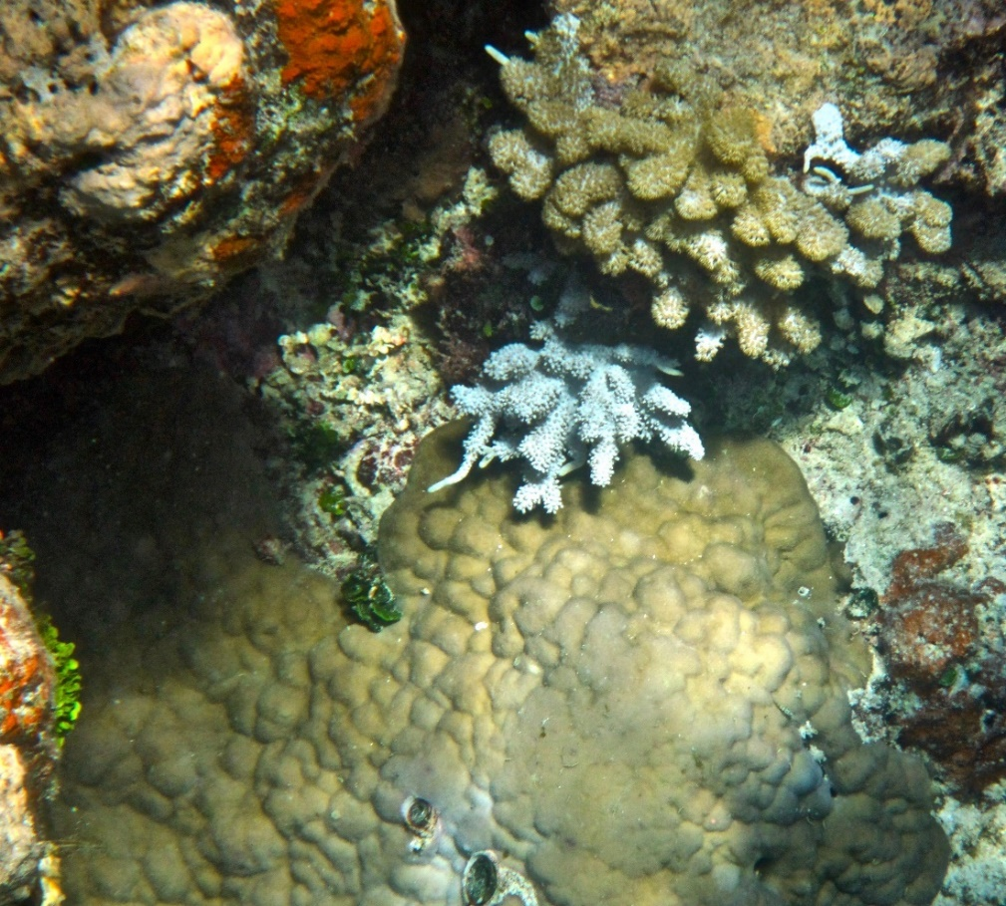
Instructions: use the photo provided from VRD to practice calculating Simpson’s Diversity Index. Since marine organisms can be very difficult to identify, look at the marked-up version of this photo to help you count the types and numbers of organisms in the photo.
Annotated Image:
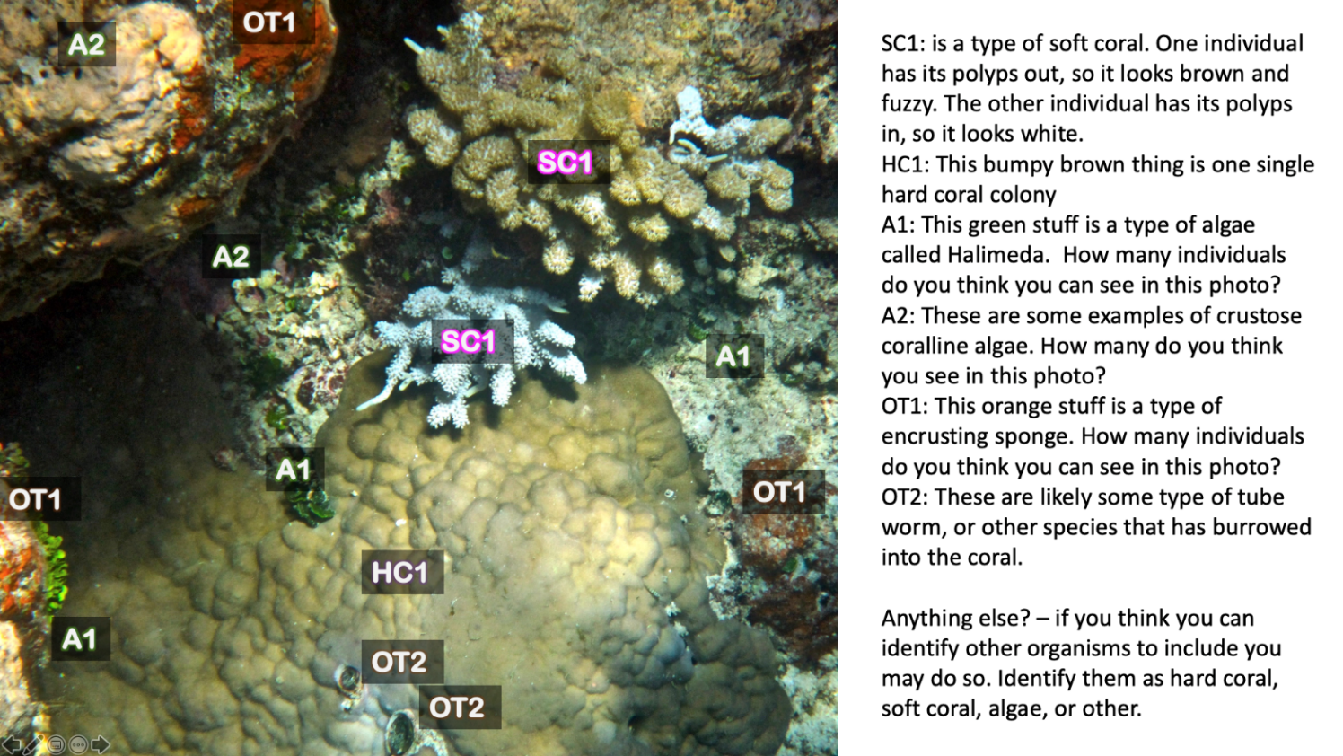
Table 3: shows the number of individuals of each biotic factor classified and the working out to determine Simpson’s Diversity Index as a measure of diversity.
Biotic Factor | Number of individuals (n) | n-1 | n(n-1)
Hard Coral 1
Soft Coral 1
Algae 1
Algae 2
Other 1
Other 2
 |  | ∑n(n-1) =

 | N | N-1 | N(N-1)
Total number of individuals (N)

Finally, calculate Simpson's diversity index (D) here | D = 1 - | ∑n(n-1)
 |  | N(N-1)
 | D = 1 -
 | D =

Discussion:
- Virtual Reef Diver uses broad categories to describe the coral reefs where it surveys. Consider at least one advantage and one disadvantage of using these categories.

- Compare the measures of diversity. (compare = similar, different and significance of each)

- Describe three limitations of the data. (this must be of the data itself, not the method used to collect it)

- Identify three sources of error caused by the method.

- “The indices used to determine diversity in this practical are not a complete representation of the diversity of the Great Barrier Reef.” Evaluate this claim.

- Research: Hard corals are an indicator of Coral Reef ecosystem health. Determine how the data collected in VRD could be used to help conservation and management of the GBR.

https://www.virtualreef.org.au/research/observation/ (Observation, classification, modelling, prediction)

- Diversity indices, biotic and abiotic factors can be used to compare ecosystems across spatial (space) and temporal (time) scales. Predict how VRD could be used to conduct such an ecological comparison on Biodiversity.

Conclusion:
Write a conclusion regarding the methods used to determine species diversity to compare ecosystems across spatial and temporal scales.

IA2 - Student Experiment Link

“This assessment (IA2 – Student Experiment) requires students to research a question or hypothesis through collection, analysis and synthesis of primary data. A student experiment uses investigative practices to assess a range of cognitions in a particular context. Investigative practices include locating and using information beyond students’ own knowledge and the data they have been given.
In the student experiment, students modify (i.e. refine, extend or redirect) an experiment in order to address their own related hypothesis or question. It is sufficient that students use a practical performed in class or a simulation as the basis for their methodology and research question.”
(QCAA, Biology Syllabus v1.2, 2019)

